
President’s Pen
Spring, 2018 Volume 3: Issue 1
CRMC Auxiliary Newsletter
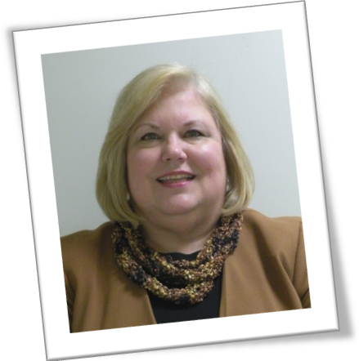
As your newly elected Auxiliary President, it is my pleasure to address you for the first time. I have been working “behind the scenes” for the past year as the 1st Vice President, supporting Marie Sluberski in her leadership role. Now, it’s my turn at the reins, and I hope I’m able to perform as admirably as she has done, and continue the Auxiliary’s successful work on behalf of our Medical Center.
Over the next couple of months, our branches will resume their activities after taking a winter break. In addition, beginning in April, the Auxiliary will repeat their very successful raffle from last year. The prize structure has been changed to benefit more winners, we hope, and the drawing will be held sooner than the Annual meeting in November, at a Fashion Show and Gala over Labor Day weekend, which will also showcase our fantastic EtCetera Shops. Watch for more details!
Watch your email for details, too, regarding our branch’s monthly meetings and luncheons, as we transition from mailing out the invitations to sending them via email. We hope this cost-saving move will allow us to decrease our expenses. Read more about this elsewhere in this newsletter.
Again, I look forward to serving for the next two years as your President. If you have any concerns you’d like to send me, you can reach me at misslilly3@comcast.net. Thank you,
Vicki

Secretary Induction
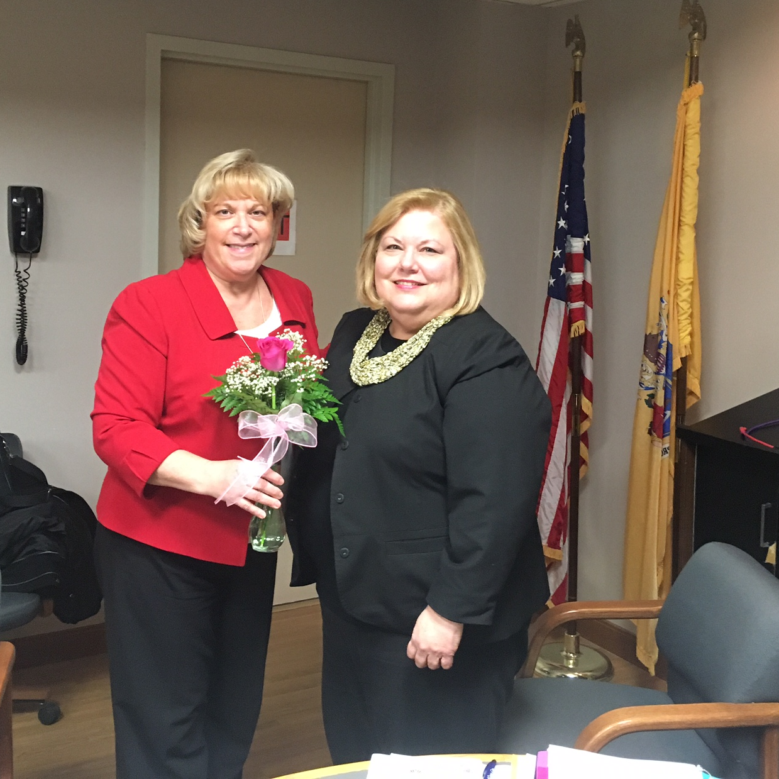
At the Auxiliary Board meeting in January, Claire Paugh was inducted into the position of Recording Secretary for the Auxiliary, replacing Marge Carter, whose term has expired.
Vicki Heebner, Auxiliary President, administered the Oath of Office to Claire. She then presented Claire with roses as a “Thank You” for accepting the office.
Vicki was installed as Auxiliary President at the December meeting of the Auxiliary, as were Marge Carter, 1st Vice President, and Kristine Poole, 2nd Vice President.
All of the other Officers and Committee Chairman will be continuing in their current roles for the next two years. Marie Sluberski, outgoing Auxiliary President, replaces Lynne Dubler as Auxiliary Past President. We thank Lynne for her many years of service to the Auxiliary.
Mailings vs. Email
At a recent meeting of the Board, it was decided that we need to try to curb our mailing and copying expenses. Each invitation or notice that goes out to our members requires the expense of color copying as well as the postage expense.
If you are agreeable to receiving all future notices via your email, then you need do nothing. However, if you would prefer to continue to receive hard copy notices and emails, then please contact your branch President and tell her that you desire to receive all your contacts via hard copy (snail mail).
We will try to accommodate all requests as quickly as possible, but please be patient if it takes a month or so for your request to be processed. Thank you.

Meet Your Board

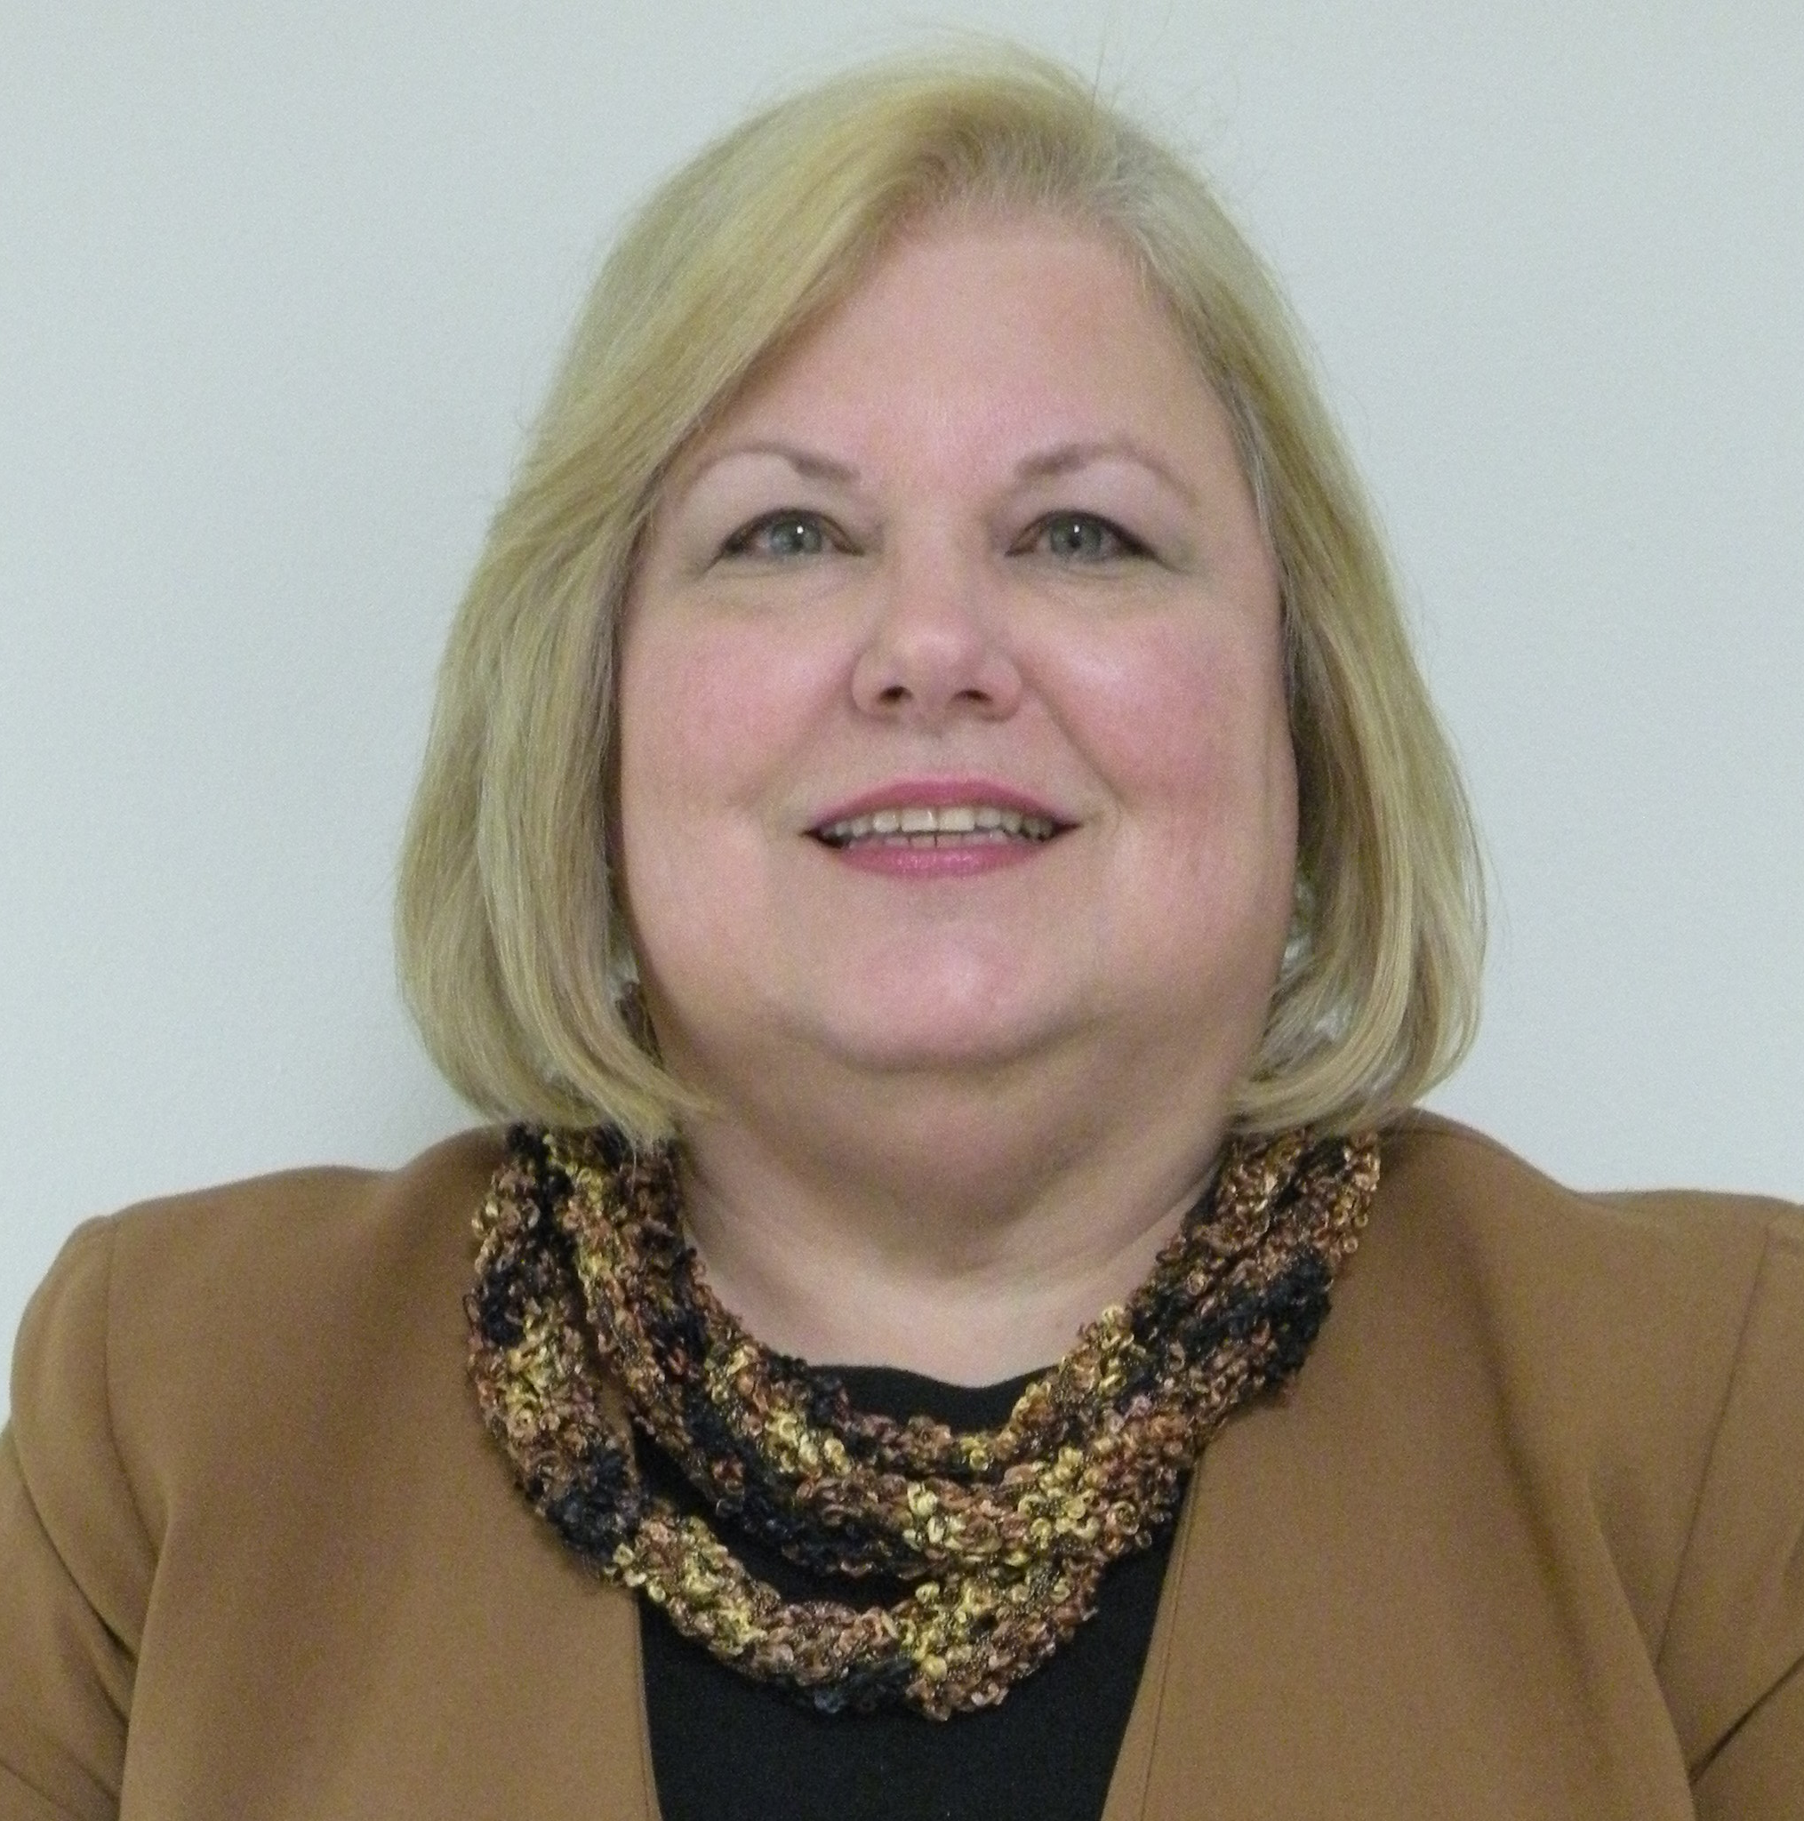
Vicki Heebner
Auxiliary President
Years w/Auxiliary: 6 + yrs

What do you see as your greatest accomplishment in the auxiliary?
I am hoping that my greatest accomplishment is yet to be. These next two years serving as President will certainly present challenges and opportunities for many wonderful accomplishments.

Why would you recommend auxiliary membership to a non-member?
I would highly recommend joining the CRMC Auxiliary for many reasons. You will have the opportunity to make new friends and utilize your talents and skills to help with a variety of projects. Best of all you will have the satisfaction of supporting your local health center, to bring needed funding for new services, facilities, and equipment.

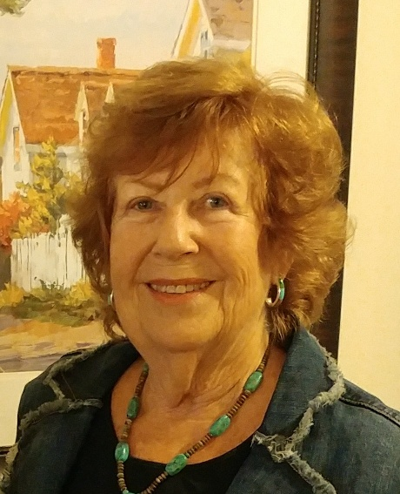
Marge Carter
1st Vice President
Years w/Auxiliary: 3 yrs
What do you see as your greatest accomplishment with the Auxiliary?
Assisting the Auxiliary in reaching the goals set forth by the past and present Auxiliary Board and maintaining and increasing the membership. Also, participating in events that will accommodate our members interests and spur attendance.

Why would you recommend Auxiliary membership to a non-member?
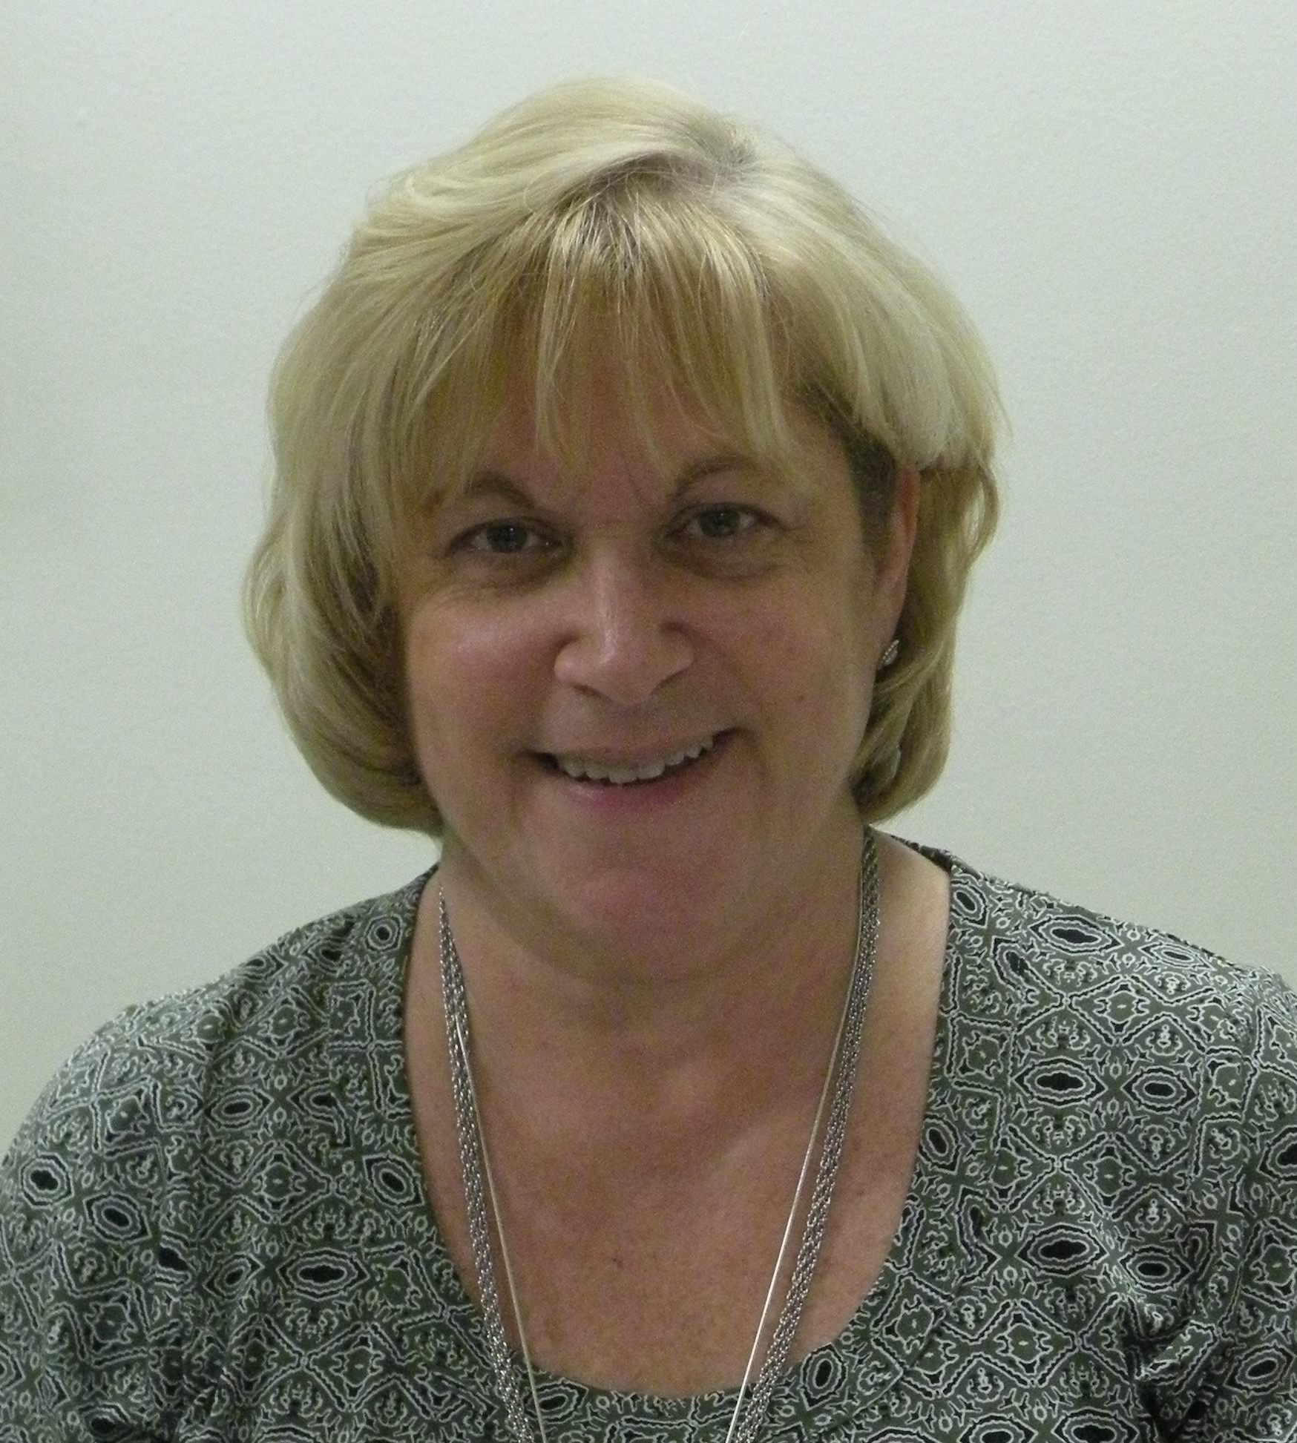
For the same reason I joined, and that is to make the neighborhood hospital, doctors and facilities the most modern, up to date, and best in the area so nobody has to travel to Philadelphia or elsewhere to receive good medical care. Let Cape Regional Medical Center be the choice of Cape May County residents. Just in the past several years CRMC has acquired more doctors, specialists, and opened urgent care facilities and is continuing to seek out and hire more as the need increases. This is a win win for all those that live here and if I can help in a small way to raise monies for some of these endeavors, I am happy to do so.

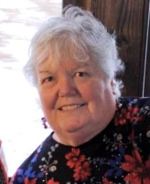
Kristine Poole
2nd Vice-President, Chairman Web and News Committee
Years w/Auxiliary: 4 yrs

What do you see as your greatest accomplishment in the auxiliary?
I volunteered to update the existing Auxiliary website, re-writing it and bringing it up to date with the changes the Auxiliary has experienced over the past several years. It’s a perpetual work in progress, but I hope that it’s kept current enough for our members (and visitors) to get useful information from it. I’m also glad to be a part of sending out a quarterly newsletter to our members.
Why would you recommend auxiliary membership to a non-member?
Every person has talents and skills that go underutilized. As a member of the Auxiliary, you can find your niche, where those talents and skills become useful and valuable to the needs of the Auxiliary. Plus, it’s a great way to meet people outside your normal sphere and make new friends!
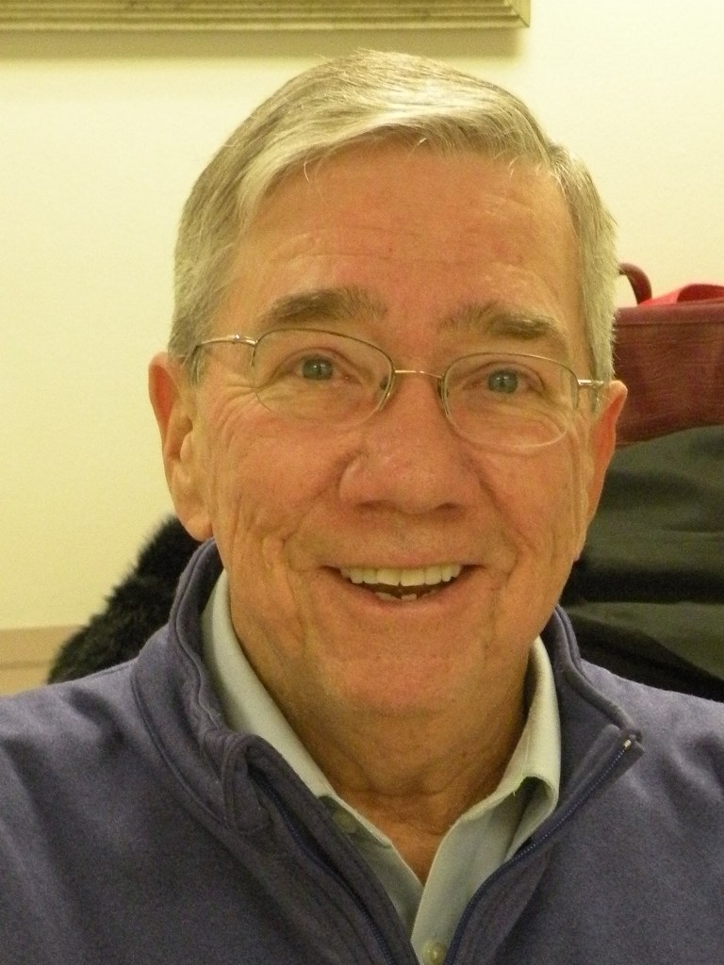
Daniel Borawski,
Treasurer
Years w/Auxiliary: 6+

What do you see as your greatest accomplishment with the Auxiliary?
I see it as being part of the team that expanded The EtCetera Shop to two locations.
Why would you recommend Auxiliary membership to a non-member?
You get a tremendous feeling of accomplishment. Knowing the organization has, even in my short time, donated over $1M to Cape Regional Medical Systems makes me feel great. Not to mention, too, how many friends you make along the way.

Claire Paugh
Auxiliary Secretary and President of Branch Team Cape
Years w/Auxiliary: 1 ½ yrs

How long have you been an auxiliary member?
I’ve been a member of the Auxiliary approximately a year and a half. A coworker and I joined as a result of the Auxiliary’s 65th Anniversary celebration in the Medical Center main hallway. I joined the Board in January of 2018.
What do you see as your greatest accomplishment in the auxiliary?
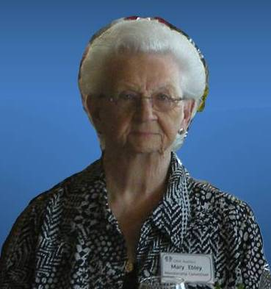
I recently worked with two other CRMC team members to create a new branch for the Auxiliary that is team-member focused. We have recruited a great team, and have many fun events planned for our inaugural year!
Why would you recommend auxiliary membership to a non-member?
Becoming involved in the Auxiliary is a great way to make new friends, participate in fun activities and events, and give back to our health system and our community!
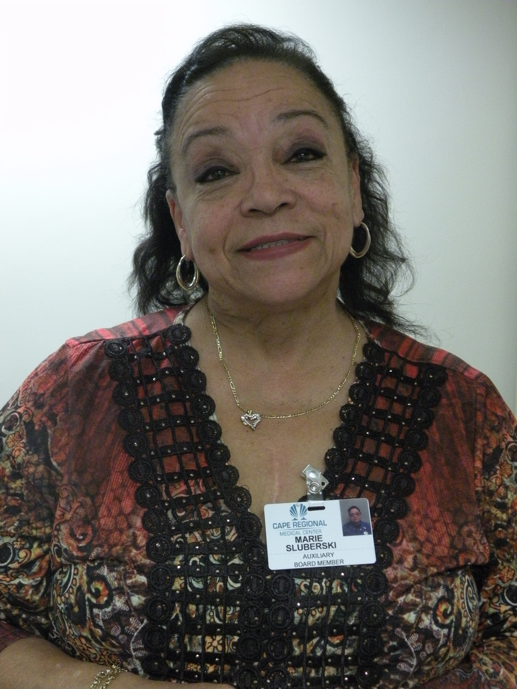
Marie Sluberski
Auxiliary Past President and Wildwood Branch President
Years w/Auxiliary: 10 yrs

What do you see as your greatest accomplishment with the Auxiliary?
My greatest accomplishment was to celebrate the 65th Anniversary of the Auxiliary by holding an Auxiliary Day at the Medical Center to introduce the Auxiliary to the employees. Posters and information were available to help inform them what the Auxiliary has been doing (for 65 years!) to help the hospital. This activity was the force behind some of the hospital employees deciding to organize their own branch of the Auxiliary! Today, we have Team Cape! And I welcome you all to the Auxiliary and look forward to working with you.
Why would you recommend Auxiliary membership to a non-member?
I promote and talk about the Auxiliary to everyone I meet. It is a great organization that does a fantastic job helping our hospital. Also, because of the people involved; their dedication is an inspiration!
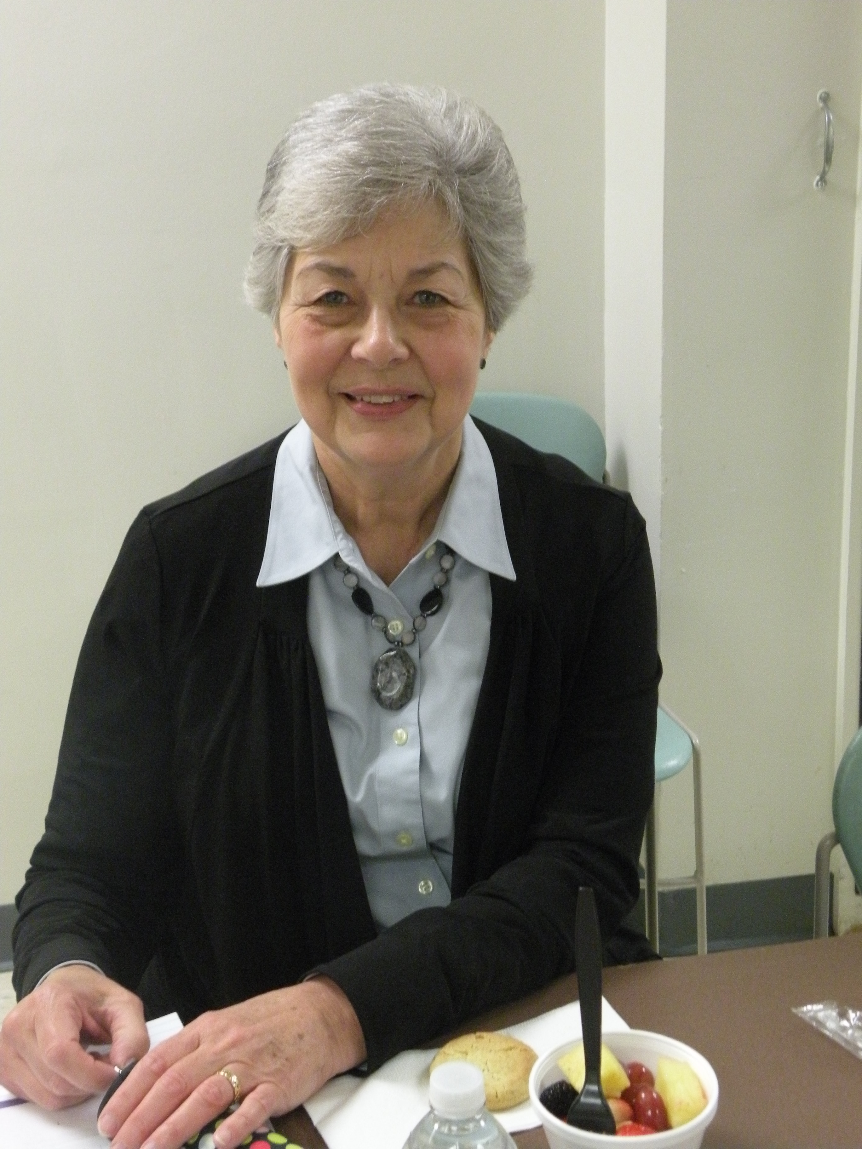
Susan Handron
Scholarship Committee
Years w/Auxiliary: 3 ½ yrs

What do you see as your greatest accomplishment with the Auxiliary?
It’s just being a part of the Auxiliary, and watching it meet its goals and objectives. I’m also proud of the work I’ve done with the Scholarship Committee; it’s gratifying knowing that we’re assisting the next generation of doctors and nurses meet their goals.
Why would you recommend Auxiliary membership to a non-member?
I’d recommend it because it’s rewarding, and you get to work with and meet new and interesting people! Your work benefits the entire community.

Mary Ebley
Chairman, Membership & Sunshine Committees
Years w/Auxiliary: 7 yrs

What do you see as your greatest accomplishment in the auxiliary?
I am proud that I have worked with as many of the Branches as possible and kept them informed of additions and deletions in their membership. I’ve participated in as many events as time would allow.
Why would you recommend auxiliary membership to a non-member?
I would recommend anyone join any one of the Branches; they all have active memberships and it’s fun to participate in their various activities.
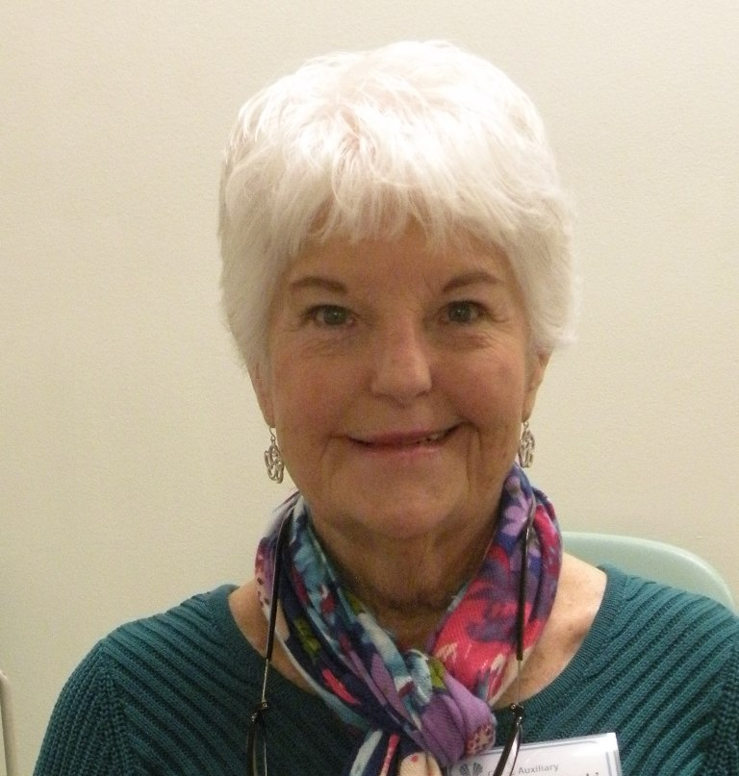
Dot Niwinski
Chairman, Vendor Sales
and
President, Cape May Branch
Years w/Auxiliary: 10 yrs

What do you see as your greatest accomplishment with the auxiliary?
Over the years I have enjoyed participating in the Home & Health Show and Antique Show. I am currently in my third term as President of the Cape May Branch. I have scheduled our Vendor Sales for the past eight years and enjoy attending our various luncheons.
Why would you recommend auxiliary membership to a non-member?
There are so many benefits of becoming an auxiliary member for CRMC. Having direct contact with the hospital, you are always up to date on the new technology being added to the hospital. It’s great to enjoy the fellowship during our fundraising activities, such as our luncheons, which are fun and informative. The fundraisers generate money to pay down our $1,000.000 pledge.
“You will have the opportunity to make new friends and utilize your talents and skills…to bring new services, facilities and equipment.”
Vicki Heebner, Aux. President

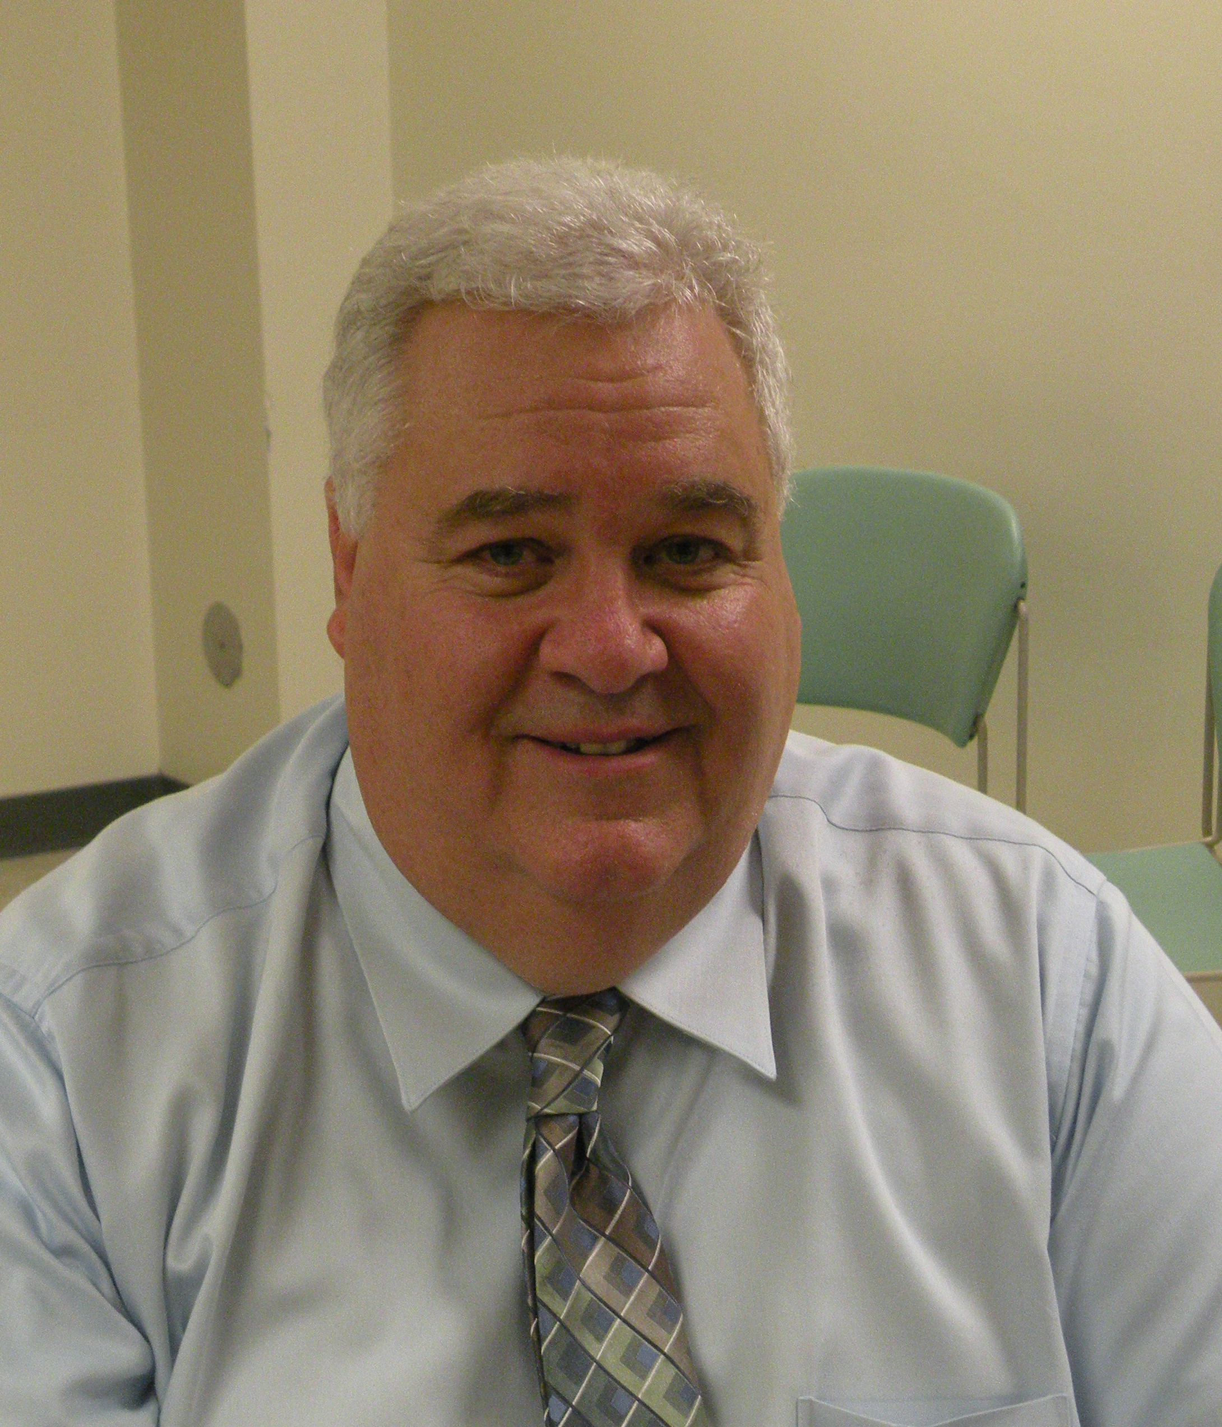
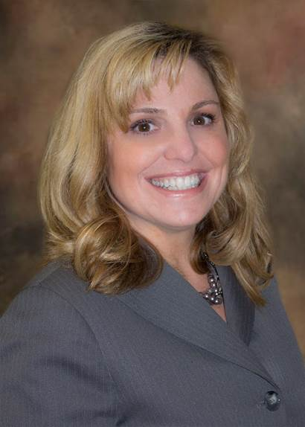
Noreen DiPadova
Vice-President,
Branch Team Cape
Years w/Auxiliary: less than 1 yr.

What do you see as your greatest accomplishment with the Auxiliary?
To date, it’s collaboratively starting a Cape Regional Health Systems auxiliary branch.

Why would you recommend Auxiliary membership to a non-member?
It is such a great way to give back to our community hospital. Plus it’s fun too!

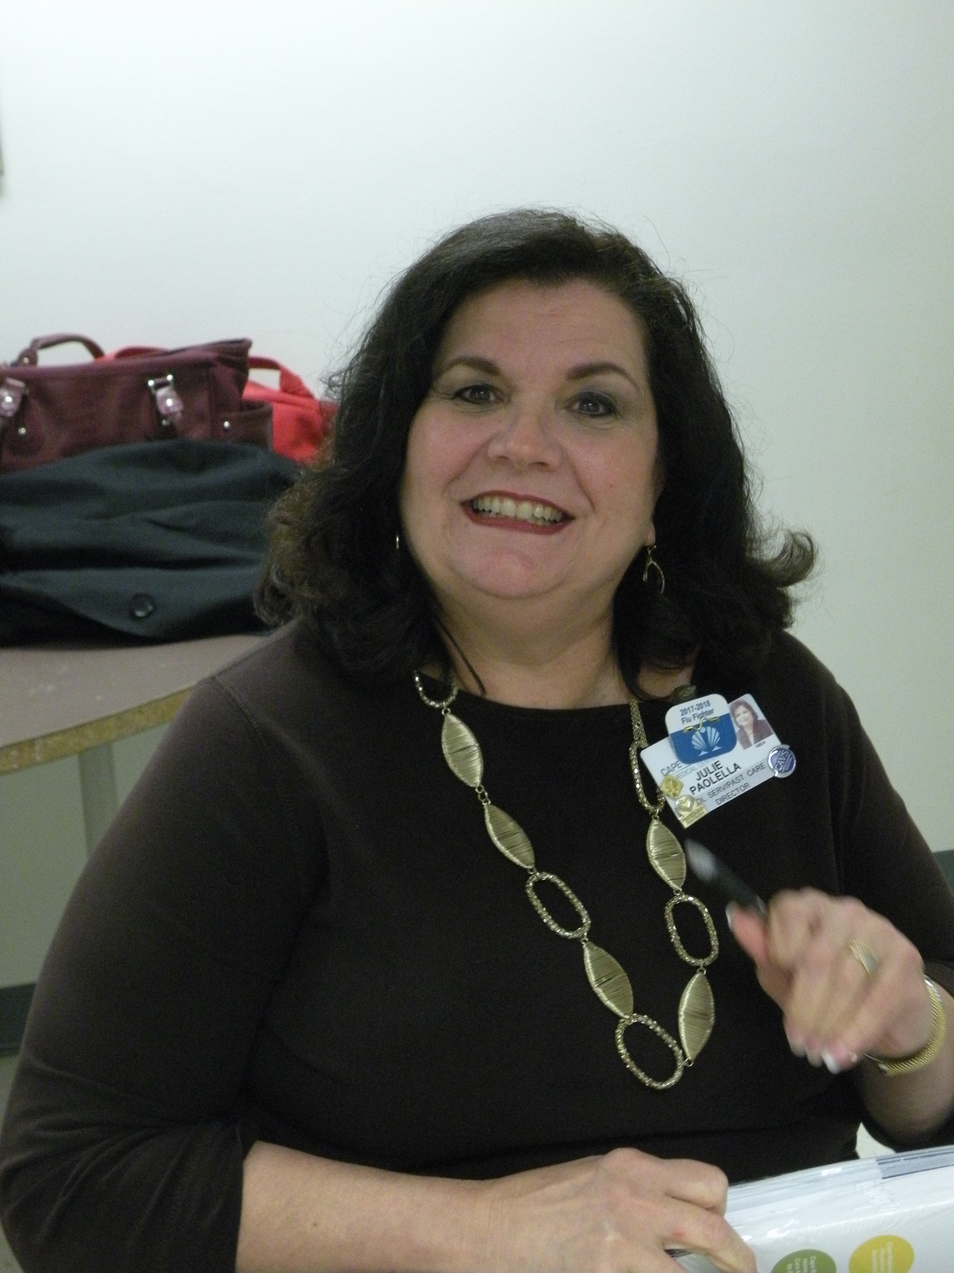
Julie Paolella
Director Volunteer Services,
Liasion to the Auxiliary
Years w/Auxiliary: 6 yrs

What do you see as your greatest accomplishment with the Auxiliary?
It has been very gratifying identifying volunteers who may be interested in serving on the Auxiliary Board; to date, there have been 8 referrals!
Why would you recommend Auxiliary membership to a non-member?
Auxiliary membership is a wonderful way to support your community hospital! As a new Auxilian, you can also choose your level of involvement, so you are able to tailor committee or project work according to your schedule and availability.

Jessica Kunie,
Manager, The EtCetera Shops
Years w/Auxiliary: 3 + yrs

What do you see as your greatest accomplishment in the auxiliary?
I love working at the shops; knowing the profits are benefiting the local hospital brings an extra level of satisfaction to the work. I enjoy knowing we are bringing needed products to our customers and at the same time, informing them that they are performing a valuable service with their purchases.
Why would you recommend auxiliary membership to a non-member?
I would recommend it because you truly get to be involved in local events with like minded people. Also, you can help spread the word about our community health system and all of the good it does on a daily basis!
Tom Piratzky,
VP, Cape Regional Foundation, Liasion to Board
Years w/Auxiliary: 17 yrs

What do you see as your greatest accomplishment in the auxiliary?
The greatest accomplishment of our Auxiliary is the ability to be so visible and be tremendous ambassadors in the communities of Cape May County as well as the many major projects they have financially supported throughout their history. Our Auxiliary is an amazing group of people very dedicated to Cape Regional and the health of our community.
Why would you recommend auxiliary membership to a non-member?
I think it is important to give back to the community whenever you can. Being a member of the Auxiliary is a fun, productive and very rewarding way to serve the healthcare needs of our community and really make a difference. The membership is outstanding and provides an opportunity to get involved to the level you so desire.
“Auxiliary membership is a great way to make new friends.”
Dan Borawski

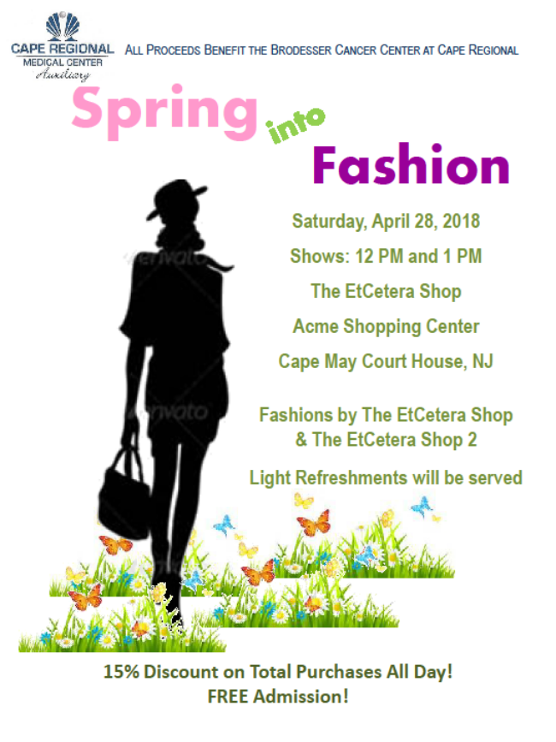
Auxiliary Branch News
The first quarter of the year is usually a quiet one for the branches. Most branches skip holding a meeting in January, and sometimes wait until March for their first meeting of the year.
The Cape May Branch held a Bakeless Bake Sale for the month of February. Members were asked to mail in their donations of the cost of a baked good. This fundraiser has netted over $530 to date. In March, they held a luncheon at Vincenzo’s Little Italy in North Cape May, where Krista Fitz-Simons from the Cape May County Department of Aging and Disability Services was the speaker. The meeting was well attended, and Ms. Fitz-Simons shared a lot of good information with the attendees, including how to deal with the so-called “Grandparent Scam” from unknown callers. She also gave the attendees very informative hand-outs of various services available in the County.
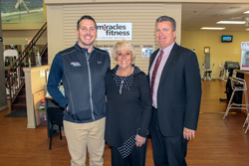
In March, the Wildwood branch held a reorganization meeting at the Lee Lane Clubhouse in Cape May Court House. Marie Sluberski was elected President; Delores Ambruso, Marie Gallagher and Dot Quill will continue in their roles as Vice-President, Recording Secretary and Treasurer, respectively.
At our March meeting, Marie Sluberski reported that the Wildwood branch will begin assembling the distribution bags for Fuzzy Friends. The order for the animals has been placed, and the animals should arrive mid-April. There are almost 70 locations where the Fuzzy Friends are available for purchase, and each location receives a large bag of assorted animals at the beginning of the season.
Above, from Left: Nick Elisano and Dottie Drake of Miracles Fitness, and Mark Gill, CFO, Cape Regional Health System.
On April 27th, there will be a meeting for all MASH members in the Maruchi Conference Room of Cape Regional Medical Center. Members interested in participating in the re-organization of this Auxiliary Branch are invited to attend. Light refreshments will be served.

Auxiliary Sponsored Raffle
The Auxiliary will once more be sponsoring a $20,000 Prize Raffle. Tickets will be available beginning in April; the drawing will take place on the Saturday of Labor Day weekend, at a Fashion Show and Gala to be held at The EtCetera Shop in Cape May Court House. Winners need not be present.
Ticket price is $100, and the prize structure is: $15,000 First Prize; $2,500 Second Prize; and Five (5) Third Prizes of $500 each. For tickets, contact any Auxiliary member, or visit the EtCetera Shops.
Tickets may be purchased with cash or check; credit card sales will only be available at either EtCetera Location: the Acme shopping center on CMCH-Dennisville Road, or North Cape Center on Bayshore Road in North Cape May.

Miracles Fitness
Mr. Tom Piratzky, VP, Cape Foundation, was very excited to announce at our March meeting that Cape Regional Medical Center has entered into a partnership with Miracle Fitness. As a member of the Cape Regional Health System family, Miracles Fitness and their dedicated staff and trainers will continue to deliver personalized service and exceptional, goal-oriented membership programs at their Rio Grande location (across 5th Ave. from Shop-Rite).
Cape Regional Miracles Fitness is a 10,000 sq. ft. facility which houses three group fitness studios, a premier fitness floor, a free weights room, an Active Aging area, and various amenities (including a juice & smoothie bar!). Dedicated trainers are available at every level, from the greenest beginner to the seasoned fitness enthusiast.
For more information, call Miracles Fitness at 609-886-7070 to inquire about the various program levels available. Or better yet, stop by and check out the facility. Someone is always available to answer your questions. Take the first step to being a healthier you!

Vendor Sales
The first vendor sale of the year was held in February. Pretty Pickins, a new vendor to CRMC, offered an upscale variety of jewelry, watches, handbags and other merchandise in a large display. Feedback from the employees said that they were thrilled to have someone “different.” The second sale was held in March, when Collective Goods (formerly Books ‘r Fun) visited.
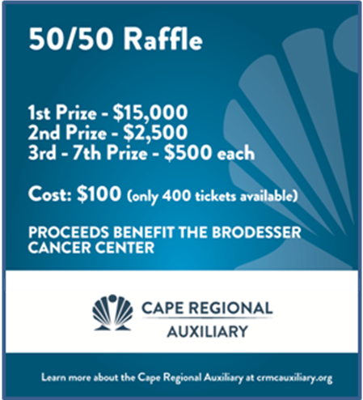

Allergy Season
Spring is coming and soon the chirping of birds won’t be the only sounds heard – the sounds of sniffling and sneezing will be a backdrop in most homes and businesses. More than 50 million Americans will be sneezing and wheezing thanks to seasonal allergies. Projected lower temperatures in the early spring mean allergy symptoms will be intense and last longer than average.
Allergies are characterized by an overreaction of the human immune system to a foreign protein substance (“allergen”) that is eaten, breathed into the lungs, injected or touched. This immune overreaction can result in symptoms such as coughing, sneezing, itchy eyes, runny nose and scratchy throat. In severe cases, it can also result in hives, rashes, lower blood pressure, difficulty breathing, and asthma attacks – even death.
Relief seems difficult as the various pollen counts soar; however, knowing what your triggers are and how to avoid these triggers make it possible to lead active, healthy, lifestyles with minimal side effects. Although symptoms may not be severe, it’s important that seasonal allergies should be properly diagnosed and treated.
While there are common rules to live by in the spring, such as keeping your windows closed, there are lesser known spring allergy elements than can cause you more misery. Here is a list of surprising allergy facts:
- Pollen counts slowly rise annually, and are expected to double by the year 2040. Global environment, increased levels of carbon-dioxide, and temperature induced changes are fueling this growth.
- Where you live can determine the level of discomfort you feel, but no matter where you live, allergies can be a problem all year long.
- Taking your allergy medication should occur long before the first sneeze. Allergists recommend taking your medication at least two weeks before your symptoms typically surface. If a stretch of warm temperatures is forecast, get out your allergy medication and take it! For severe allergies, allergy shots can lessen and prevent disease progression.
- A mild winter may cause an early release of pollens from certain trees, and a longer allergy season. Once an allergy sufferer is “primed” by this early exposure, their systems may experience little relief even when temperatures rise and the pollen count is reduced.
- Common folklore holds that pollen counts will drop with spring showers. Unfortunately, the opposite is true as rain can promote plant and pollen growth. Accompanying rainfall can stir pollen and mold in the air, heightening symptoms.

CRMC Auxiliary Executive Board:

Vicki Heeber President
Marge Carter 1st Vice-President
Kristine Poole 2nd Vice President
Claire Paugh Recording Secretary
Dan Borawski Treasurer

CRMC Branch Officers:
Cape May Dot Niwinski, President
Dottie Hastings, VP
Wildwood Marie Sluberski, President
Delores Ambruso, VP
MASH TBA
Team Cape Claire Paugh, President
Noreen DiPadova, VP
TWIGS Lynne Dubler, Liasion

Committees:
Nominating Wilda Richardson
Membership/Sunshine Mary Ebley
Scholarship Susan Handron
News & Web Kristine Poole
Vendor Sales Dot Niwinski

Liasions to the Auxiliary:
Julie Paolella Dir of Volunteer Services
Tom Piratzky VP, Cape Foundation

